**Assumptions**:

Process assumptions:

We are assuming that each of the I/O bursts follows CPU bursts. We are assuming no processes attempt to access the same data at the same time or at any time. The processes will not access any data / memory when running and will either be ready, running, new, waiting, or exit states.

Simulation assumptions:

We are simulating the start-up of a computer which results in all of our processes to be made ready as soon as the simulation algorithms begin rather than at their arrival time. We are also assuming that only one process can be running it’s I/O at a time, so they must be sequential rather than simultaneous.

Processor assumptions:

We are assuming switching context only takes 2 clock ticks as the process enters and exits the processor. We are assuming there are no hardware failures nor process errors that would halt the process.

**Graphs**:

*Average Turnaround (Tt)*

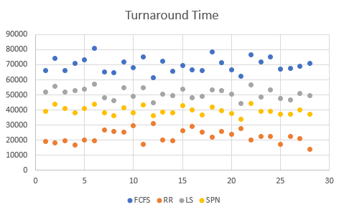

*Average Wait (Wt)*

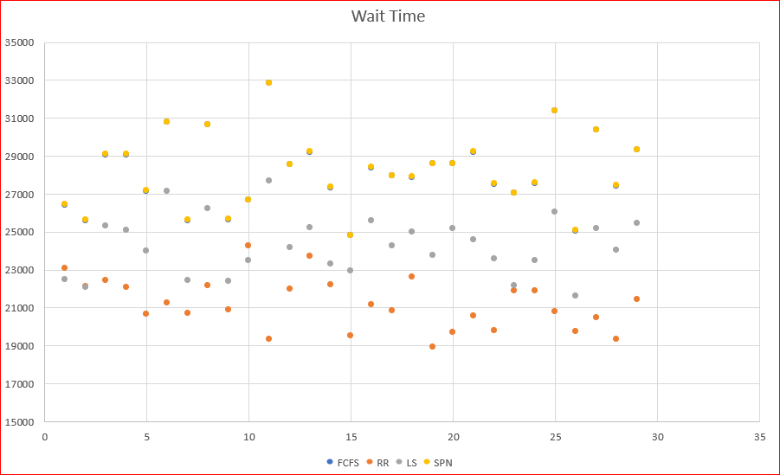

*Average Response (Rt )*

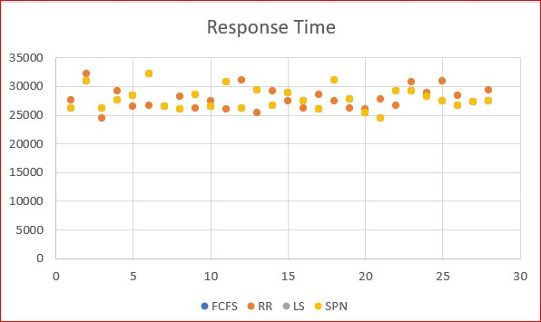

*Average Throughput (Th): Processes/Clock Tick*

*First Come First Serve: .004927*

*Round Robin: .28966*

*Load Sharing: .006217*

*Shortest Process Next: .00667*

*Speedup analysis*

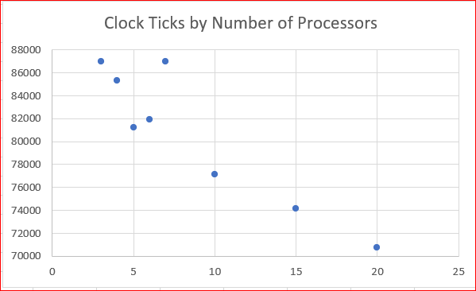

***Report data collection:***

***Files with data attached in Git repository…***

<https://github.com/AaronTheBaron15/OS-sim>

(Pete, you should have access to our OS-sim repo, since you were added as a collaborator. If you have issues let Aaron know because he made the repo. Thank you!)